<Machine Learning Term Project - Flight Recommendation System>
Group C
202034916 Park Seonjun
202234911 Rhyu Yeonyi
202235118 Jung Soyeon
* Source code&Dataset

1. Project Overview
1.1 Background and Objectives
There are ongoing reports of passengers receiving unfair or unsatisfactory treatment from airlines. Since the in-flight experience strongly affects overall trip satisfaction, this project aims to develop a system that recommends the most suitable airline or flight for each user based on user ratings and service factors (e.g., seat comfort, cabin crew service).

1.2 Datasets
This project utilizes two airline review datasets
Dataset 1:
Source: Kaggle Airlines Review Dataset (airline.csv)
Samples: 41,396
Columns: 20
Key Fields: Author, airline_name, overall_rating
Dataset 2:
Source: Skytrax Reviews Dataset (airlines_reviews.csv)
Samples: 8,100
Columns: 17
Key Fields: Name, Airline, Overall Rating

2. Data Preprocessing
Steps 1. Column Removal: Removed columns absent in test data or irrelevant to similarity computation (review dates etc.)
Steps 2. Missing Values: Test dataset had no missing values from the start
[Train Data set] (Raw data & Result)
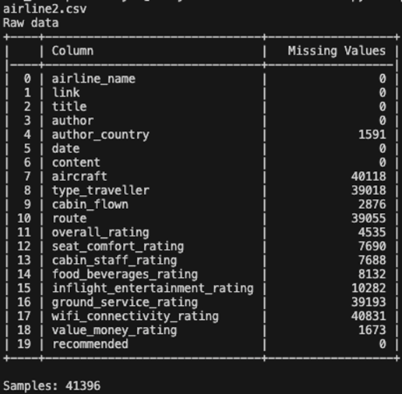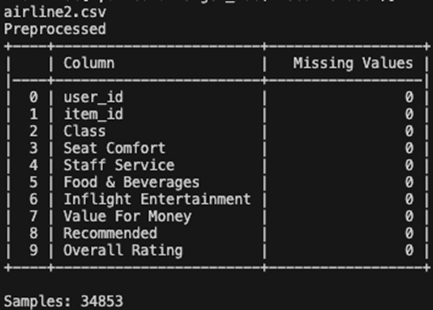
[Test Data set] (Raw data & Result)
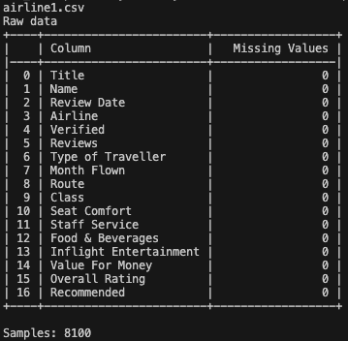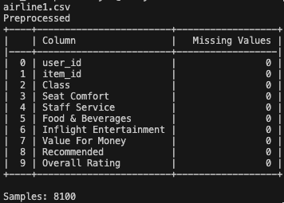

3. Methodology: (1) Hybrid User-Based Collaborative Filtering
3.1 Algorithm Overview
This project employs a Hybrid User-Based Collaborative Filtering approach with the following characteristics:
- Only consider users who appear more than three times: To ensure reliable recommendations, only users with at least 3 rating records are included in the analysis
- Model knows other users' scores and recommendation status: The model has prior knowledge of other users' ratings and recommendations (Warm Start scenario)
- Users provide one of their own evaluation records: Users must submit one of their rating records as input
- Compute similarity by comparing the provided records with the records of other users: Similarity is calculated between the user's provided record and records from other users
- Provide airline recommendations to user: Predict whether an item that a user has rated will be recommended, and measure performance based on this prediction accuracy

3.2 Core Algorithm Steps
Step 1. User Preference Learning : For each training user, a personalized preference weight vector is learned using Ridge Regression.
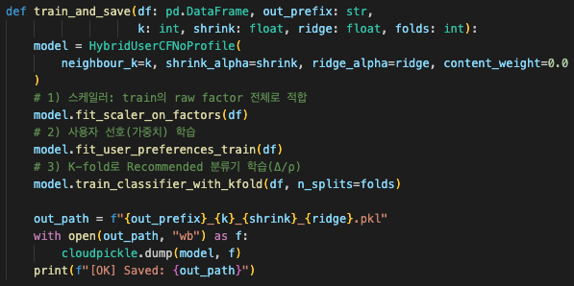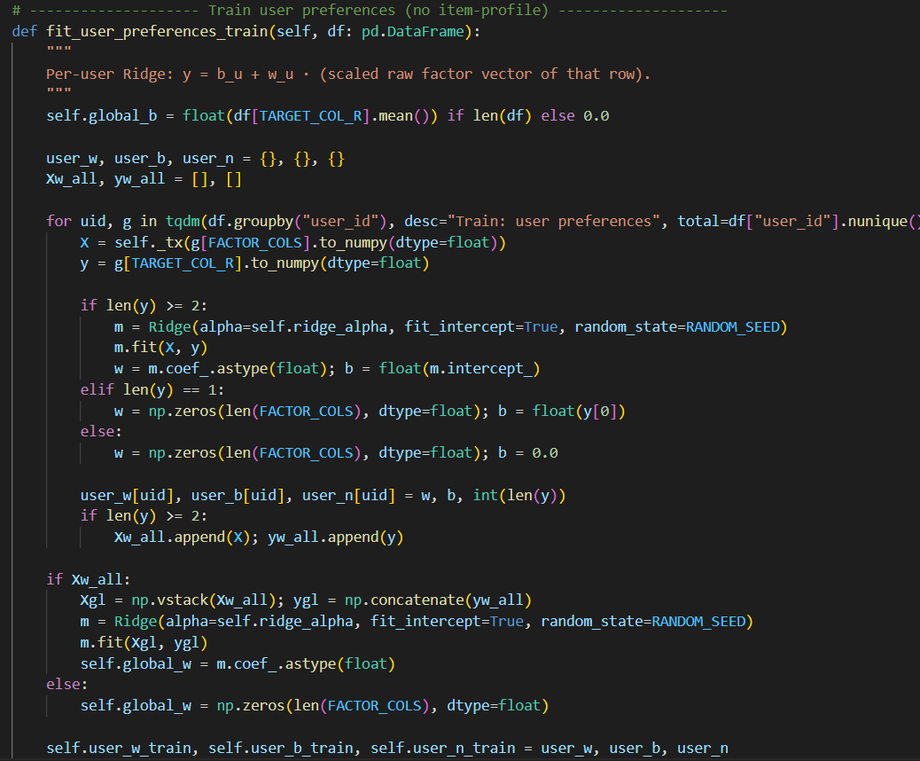
- Each training user learns how much weight to give to the six service factors (Class, Seat Comfort, Staff Service, Food & Beverages, Inflight Entertainment, Value For Money).
- w_u (weight vector): Represents user preference patterns, e.g., "User A values seat comfort, User B values food."
- b_u (bias/intercept): The user's rating tendency (whether they tend to give high or low ratings).
- global_w, global_b: The average preferences of all users.

Step 2. Test User Preference Estimation (1-Shot Learning)
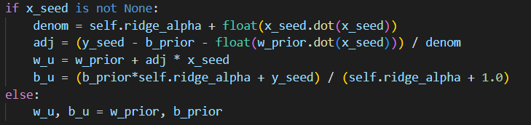
- The test user is a new user not present in the training data. Their preferences are estimated using only a single rating (seed).
- It predicts, "This test user is likely to have the following preferences."

Step 3. Neighbor Discovery with Shrinkage

- Reliable neighbors are found using cosine similarity and shrinkage.
- Shrinkage meaning:
- Users with many ratings → higher reliability → larger weight
- Users with few ratings → lower reliability → smaller weight
* Example: For item B, User1 has 2 ratings, User3 has 1 rating.
Similarity between User2 and User1 = 70%
Similarity between User2 and User3 = 70%
After applying shrinkage: User1 > User3 (users with more data are considered more reliable).
- Determines "how influential this user is for recommendations."

Step 4. Collaborative Filtering Features
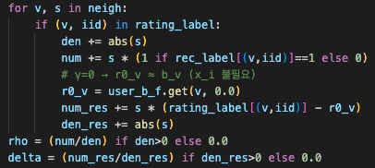
- Rho (ρ): Recommendation ratio. How much did similar users recommend this item? – “How similar must a user be for their recommendation preferences to align with mine?”
- Delta (Δ): Rating residual. Meaning: adjustment considering users’ rating tendencies (strict vs. lenient).
- r0_v: User’s overall rating mean → baseline rating tendency.

Step5. Recommendation Classifier

The previously calculated features are fed into a Logistic Regression model to predict the final recommendation outcome.

Step6. Evaluation
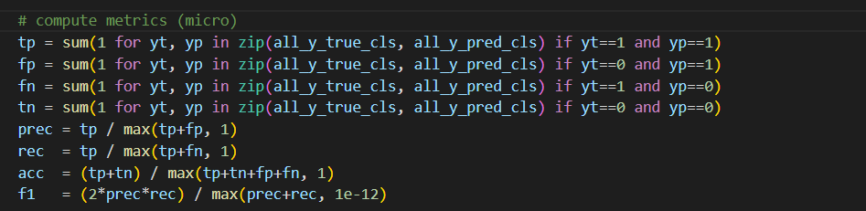
- The model’s predictions are compared with the items the test users actually recommended to measure performance.
- Metrics: Precision, Recall, Accuracy, F1.

[Result]
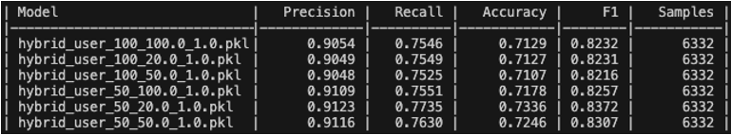

3. Methodology: (2) Content-Based
  - Algorithm Overview
This project employs a Content-Based approach with the following characteristics:
- Build item profiles from users’ aspect ratings: Item profiles are created from users' aspect ratings and are smoothed using Empirical Bayes to ensure reliability.
- Users provide one of their own evaluation records: Users must submit one of their rating records as input.
- Model knows other users' scores and recommendation status: The model has prior knowledge of other users' ratings and recommendations (Warm Start scenario).
- Compute item similarity as the cosine similarity: Item similarity is calculated as the cosine similarity between the constructed item profiles.
- Provide airline recommendations to user: Predict whether an item that a user has rated will be recommended, and measure performance based on this prediction accuracy.

  - Core Algorithm Steps
Step 1. Item Profile Construction & Normalization (Scaled + EB Smoothing): The feature vector (service factors) for each item (flight/airline) is constructed.
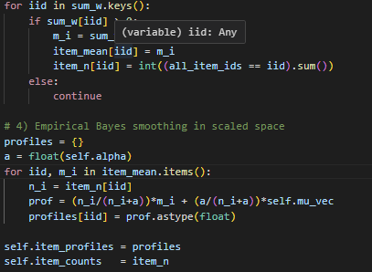
- The entire set of raw factors (ratings) is first transformed into a common scale space using Standard Scaler.
- A weighted mean vector is computed for each item, using user ratings as weights.
- Empirical Bayes Smoothing is applied: items with few reviews are smoothed toward the global mean, while items with many reviews are dominated by their own mean rating to enhance profile reliability.

Step 2. Item Bias Construction: The mean rating (Item Bias) for each item (airline/flight) is calculated. This value serves as one of the input variables for the Rating Calibration Regression model in Step 4.
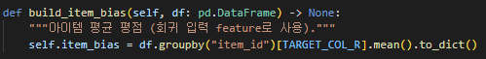

Step 3. Calibration Data Pair Generation: Pairs of items rated by the same user are extracted in the format (Seed Item, Target Item) to generate a dataset for regression training.
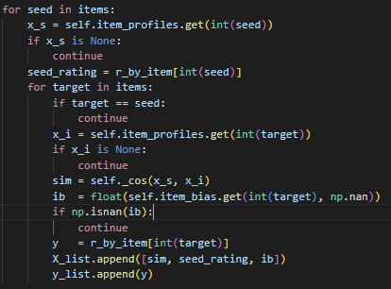
- Each pair is formatted as $X=[Sim\left(Seed, Target\right), Rating\left(Seed\right), Bias\left(Target\right)]$ with the target being $y = Rating(Target)$
- $Sim(Seed, Target)$is the cosine similarity between the two item profiles.

Step 4. Rating Calibration Regression Training: A small Linear Regression (Ridge) model is trained using the data generated in Step 3.
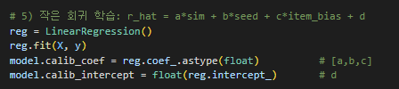
- This regression model uses similarity (Sim), Seed rating, and Item Bias to calibrate the predicted rating ($\hat{r}$) of the Target item.
- The prediction follows the form: $\hat{r}=a*Sim+b*Rating\left(Seed\right)+c*Bias\left(Target\right)+d$ with the output clipped to the [1, 10] range.
Step5. Recommendation Threshold Learning (Global $τ$): The model learns a global threshold($τ$) that maximizes the F1 Score to determine the final recommendation outcome (Recommended=1 or 0)
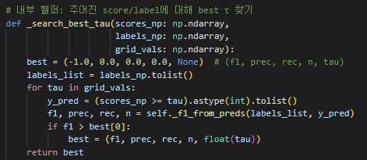
- The model uses either the cosine similarity $\left(Sim\right)(sim-mode)$ or the calibrated rating($\hat{r}$) (Rating-mode) as the prediction score15.
- It analyzes whether recommended items are more similar than items that are not recommended to set $τ$.
- The model also learns separate pattern thresholds ($τ_{pose} and{ T}_{neg}$) based on the Recommended status of the Seed item (1 or 0).

Step6. Evaluation
- The model's predictions (Recommended/Not Recommended) are compared against the test users' actual recommendation status to measure performance.
- Metrics: Precision, Recall, Accuracy, and F1 Score were used.

[Result]

4. Limitation Analysis
The Hybrid User-Based Collaborative Filtering and Content-Based Filtering methodologies employed in this project have the following key limitations:
- Warm Start Only (Dependence on Seed Rating)
- Both models are designed to operate exclusively in a Warm Start scenario, requiring the user to provide at least one evaluation record (Seed Rating) to estimate their preferences.
- This imposes a fundamental limitation: the system cannot provide recommendations to Cold Start users—new users with absolutely no prior rating history.
- Global Decision Boundary
- The recommendation decision relies on a Global Decision Threshold ($τ$ or Logistic Regression boundary) applied uniformly across all users. This approach fails to account for individual differences in recommendation sensitivity, restricting the depth of personalization.
- Inability to Directly Reuse Learned Similarities
- The internal parameters (user preferences, item profiles) learned during training cannot be incrementally updated or reused when new data arrives. This forces the model to be recalibrated or fully retrained frequently, significantly increasing the operational cost and limiting real-time scalability in a dynamic environment.

